Dan and Isaac’s Very Fine Adventure
September 2 to September 9, 2013
D. Crabtree

Day 1. The great Mt Rushmore adventure started this morning at O –dark thirty (interpreted as 0445 wakeup). We were gone by 0600. All packed the previous night – just waiting for the alarm to say, “GO!” We headed west on CA 178 to US 395 and north toward Bishop, California. We settled in for the day’s ride to Ely, Nevada. Not 10 miles up the road we hit rain. Hope this is not a harbinger of things to come. A light rain falls – just enough to get my attention for caution. The prize is a very, very bright double rainbow. Blues and greens were visible. Isaac took the pictures as we rolled up the road.
The camera man is Isaac. Number three of six grandchildren. He is thirteen and this is his first adventure with Grandpa. We have been doing work up rides but the longest has been about 350 miles. So, there is question in my mind about whether he can hack the anticipated 3000 miles.
The camera is a small KODAK Sport. Capable of 2000+ photos including videos. Isaac took 800 pictures so we have a lot from which to choose. We attached a lanyard to the camera so that he could operate it while under way without fear of it becoming road kill. He wore the get up around his neck. It worked very well. Some of the photos are blurred—a speed issue. But there are many surprisingly excellent pictures of the country side and various things of interest. And-- he did not drop or lose the camera on the entire trip—I love lanyards. I also packed a Cannon Power Shot SC150. This is a great compact camera that can be set up on a tripod to take pictures with a timer, although it eats batteries. So if you use a camera like that make sure to pack extra batteries. I took about 100 photos. Most were excellent quality—the content is a question for the beholder.
One addition I made this trip was a SPOT messenger. It has a GPS receiver and can, at 10 minute intervals, report your position. The reports go out as predetermined messages (Lat. Lon. location) via a satellite uplink feed to a central location and is then forwarded to predetermined email accounts. Your designated recipient(s) of the messages can plot your travels on a Google map. There is a button if you need assistance and a separate “call for help” button for emergencies that is tied into an international network of emergency response. The neat thing is that if you have a problem your exact location is known so long as you have the messenger in hand. Mrs.C. felt much better about me taking off when I demonstrated how the thing worked and how she could track my travels. Works great.
The transportation: 2005 BMW R1200GS with hard cases and trunk. Two Wolfman dry bags were added for good measure to hold our personal gear. These worked very well as we did hit rain—periodically, some of which were pretty significant downpours. The bike was top heavy when fully loaded and Isaac sitting in pillion, so low speed control was an issue—which was not too often—but we did land at motels each night. So parking lots, stop lights, and stop signs were “sit still and quit squirming” times. Once under way there were no issues.
The plan: Dan and Isaac’s very fine adventure consisted of riding up to Bishop, CA then on to Ely, NV. From there head up to Vernal, UT via Wendover, UT and Salt Lake, City UT, to see the Dinosaur National Monument. From there roll to Casper, WY and then wander through the Black Hills in South Dakota making our way to Mt. Rushmore ending at our turn around point in Rapid City, SD. From Rapid City high tail it through southern Montana to Bozeman, MT to get set for a ride through both the Yellowstone National Park and the Grand Teton National Forest, north to south, to Jackson, WY. Form Jackson roll to Arco, ID then on to Wells, NV, Winnemucca, NV and then home via Fallon, NV and Bishop, CA. The plan was for seven to ten days which allowed for bad weather and other contingencies. In all we anticipated a 3000 mile odyssey to see some of the most spectacular scenery in the world.
End of Day 1. 447 miles.
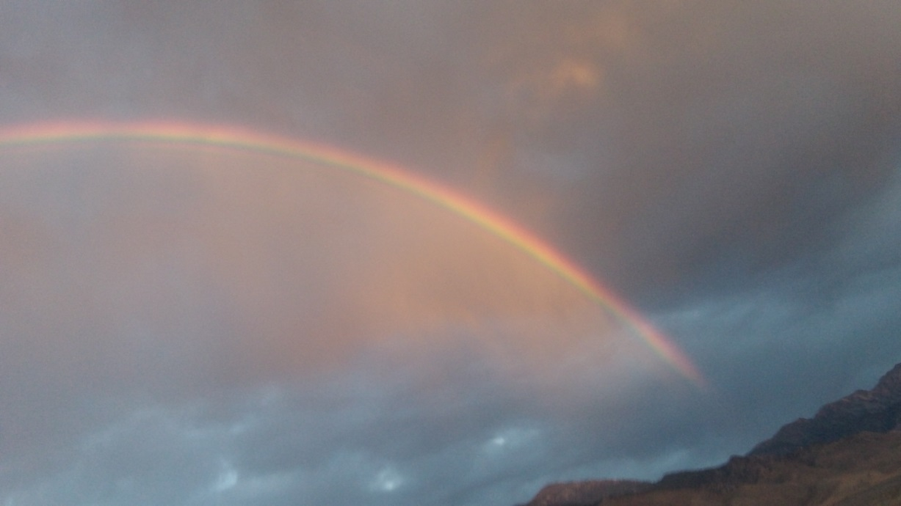
The greens were very intense. Good to start the trip with a rainbow – however there was rain also.
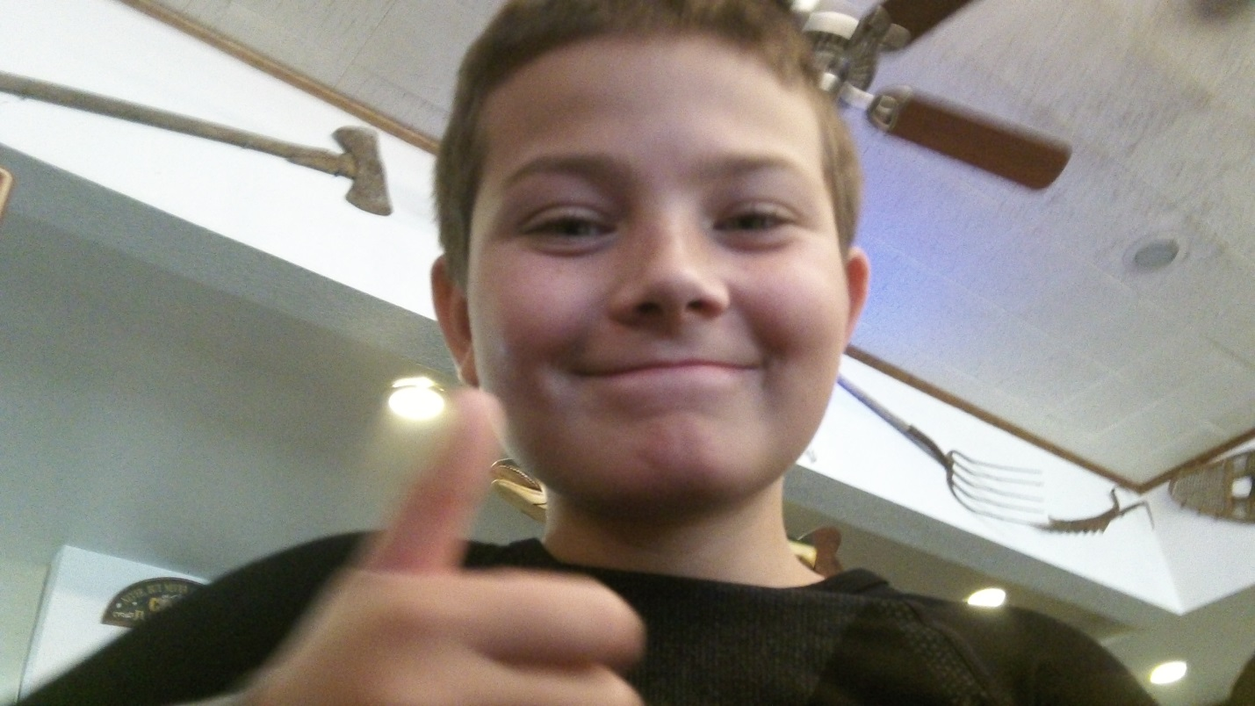
My camera man, Isaac.
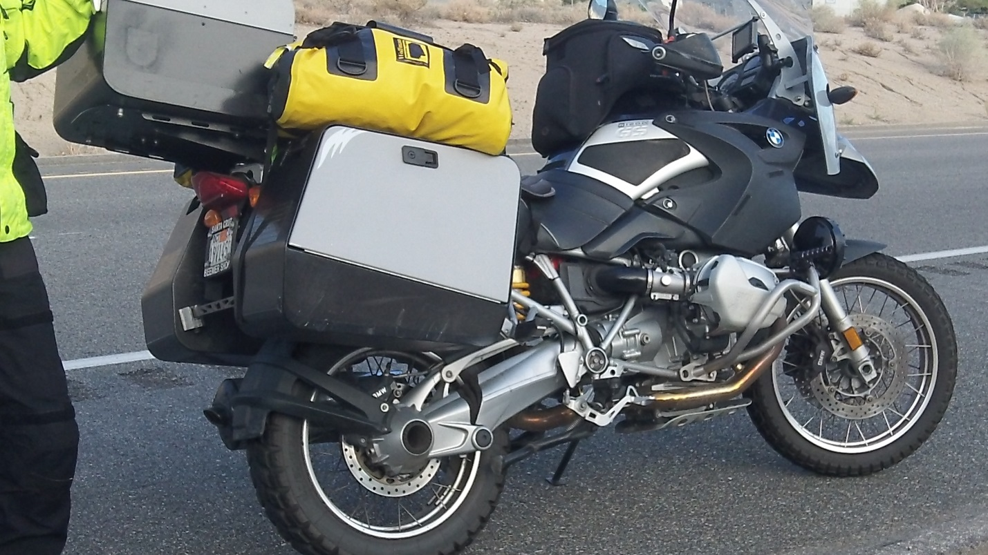
Our steed. OK, I named it Traveler. It’s fun. Get over it.
Day 2. There is lots of beautiful country, especially around Salt Lake City. Isaac has been making movies as we travel along. When we get home I will post them if I figure out how. Oh, did I mention rain. Yes there was rain. Sitting in the Silver State Restaurant in Ely, having breakfast, we watched the sky getting darker and darker when it should be getting lighter and lighter. Then Bam! Rain! We left Ely in rain with accompanying lightning that appeared to be just warming up for some significant showers later. We out ran the storm riding north to Wendover, UT. We got rained on periodically all day. We headed east to Salt Lake City on I80. This was a fast ride to pick up US 40 with Vernal, UT, our day’s destination) where our Motel 6 room awaits us. This is stark but magnificent country. Why people go to Europe to see the scenery and don’t bother traveling across the U.S. is a mystery to me. This is one Great Big Beautiful Country. But you can’t tell that if you fly over it. You have to be in it. Two wheels is the best way to see it—in my humble opinion. We are going to the Dinosaur National Monument tomorrow before we head out to Wyoming---EEEHAH!!!
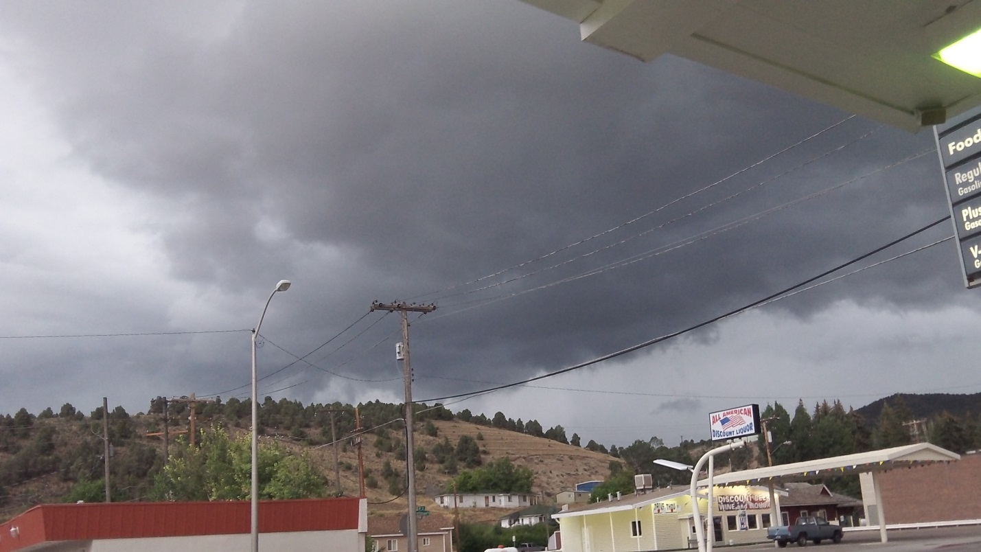
It was getting darker when it should have been getting lighter. Time to get gone.
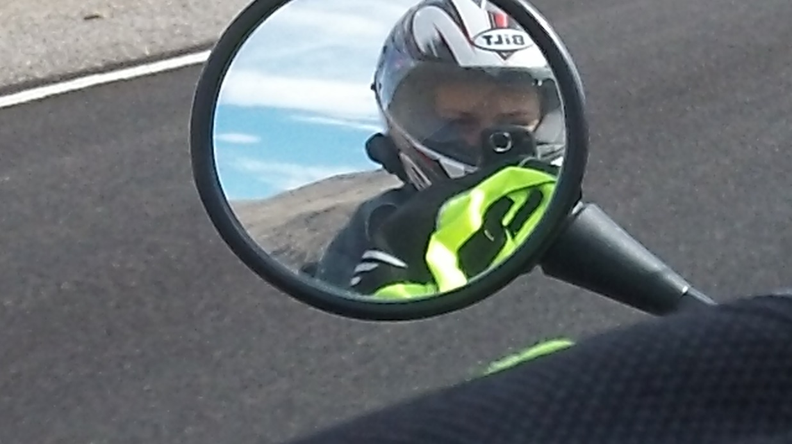
My camera man entertaining himself.
End of Day2 440 miles.
Day 3 and 4 puts us at 1500 miles. Day 3 started with the trip to the Dinosaur National Monument. Very cool! Rolled on down US 40 and picked up CO13/WY789 at Craig, CO and north to Rawlins, WY. We headed north on WY220 to Casper. This is very beautiful country but not much out here. We visited the Dinosaur National Monument near Vernal, UT and ended the day in Casper WY. It was a good day until we pulled into the Motel 6 parking lot at which time Isaac got introduced to a 0 mph tip-over. Steep entry, extra weight up high and I slowed to get through a steep rain gutter on the sidewalk---too slow. Over we went. Nothing but a few scratches on my side cases (to add to the ones already there, and yes I put them there). Only my pride was injured. Day 4 was an easy day--about 250 miles. We rode from Casper to Douglas, WY on I25 then picked up WY 18 to Newcastle, WY. The electronic signs blared away that there was an escaped convict so “do not pick up hitchhikers.” We have no room – so no problem. From Newcastle we rode US 20 east to South Dakota and the Black Hills, rolling toward Mt. Rushmore. I will definitely be coming back. Beautiful just doesn’t describe it. Mt Rushmore (Rapid City was our furthest point east) is our turn around point so the rest of the ride is going home. We spent several hours here admiring the monument, having lunch (and ice cream), and visiting the museum. This monument was built with very simple tools and dynamite (got to have it for granite). The amazing thing is that the monument was built with very simple tools. A great monument to the presidents is also a great testament to human ingenuity. Additionally, the monument is always changing. Lighting and clouds, and today it was rain, change the way it looks. It was worth the ride—every sore butt minute of it. By the way, the presidents say, “Howdy.” We saw the Crazy Horse monument as we rode by to Mt Rushmore. We ended the day in Rapid City, SD. Tomorrow will be a big day. We need an early start and at least 500 miles through Montana. My aching butt (just a little bit). Isaac claims his butt doesn't hurt. I think he's lying to his Old Grandpa and tell him so. But he does have a butt pad made of medical foam. Stay tuned on this one.
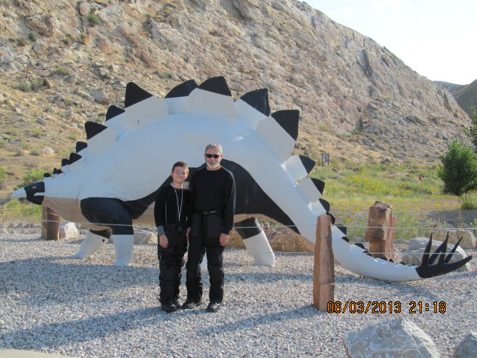
A fellow visitor to the dino monument helped us out with a picture.
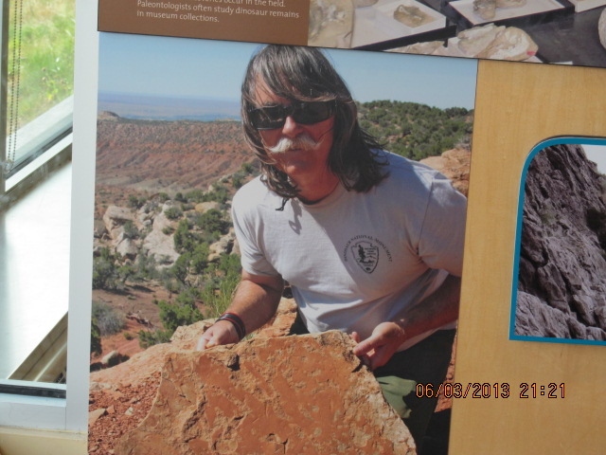
OK. How did Bob Smith get into the act? I have no idea who he is. A picture at the visitor center BUT same “era” as Bob.
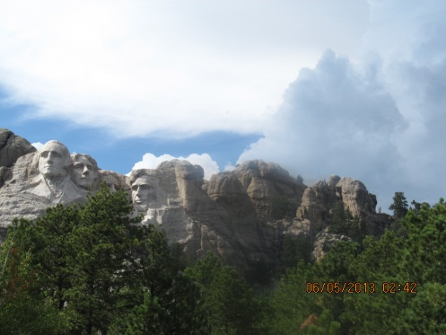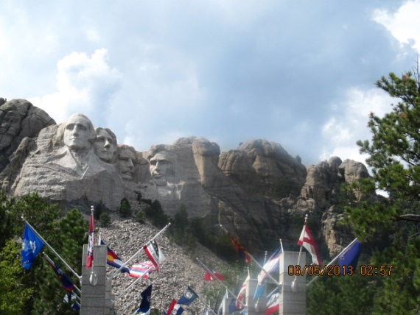
A rain storm is on the way. The monument changes as the light changes. Magnificent. Oh, and I moved a bit to get the tree out of Teddie’s mustache.

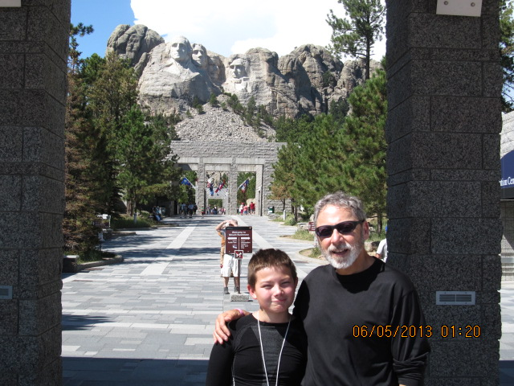
No, the old guy on the right is not part of the monument.
End of days 3 and 4.
Day 5. We rolled from Rapid City, SD through Wyoming and on to Bozeman, MT. I remember my Dad talking about Bozeman when he was a young man in the Civilian Conservation Corps (CCC) before WWII. I wanted to at least say that I have been here even if its sitting in a Motel 6 for the evening. I love riding in Montana. The speed limit on the interstate is 75 MPH with no complaints about 80 mph and 70 mph on the secondary roads in the daytime. Wonderful! That's how we traveled 500 miles in so few hours. A beautiful day was had by all but rain at the end--with lightning finished us off. We skirted the major part of the rain but the lightning was quite a show. Isaac said if he raised his sun visor (sun glasses on his helmet) the clouds weren't so dark and scary. Makes sense to me. We saw lots of horses crossing Montana and an antelope or two. Road work required a bit of off road finesse as the pavement has been removed and is being replaced. Isaac captured some pretty good video and pictures. Sitting right at 2000 miles and headed home through Yellowstone National Park and the Grand Teton National Forrest and then on to Arco, Idaho. Note Isaac was flirting with a lady biker from New Zealand who is up with a group of Harley riders touring the U.S. He walked off and forgot not only his jacket but all of the rest of his gear while he was talking to her. I told him to quit flirting and get his gear -- loud enough for everyone around to hear. The lady laughed—and got the joke –at his expense. This is a story to pass along to his Mom and Dad. Good humor and laughs along the way is good tonic.
End of day 500 miles.
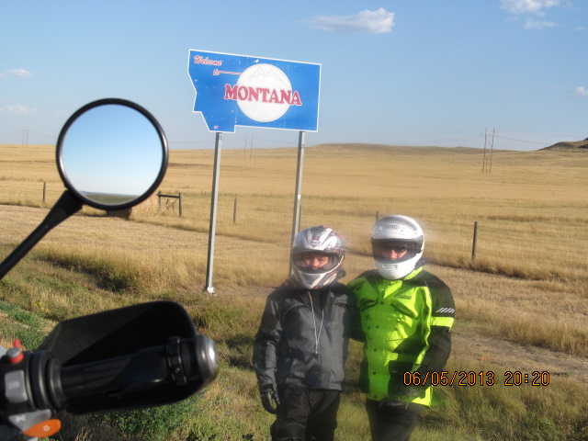
Montana. Speed limits actually make sense.
Day 6. We rolled out of Bozeman, MT --- early. It is pretty cold on the bike. We rode east to Livingston, MT and then south to Yellowstone National Park. Riding east early in the morning is murder looking into the sun. Twenty bucks gets you into the national park and is well worth the money. We did our obligatory stop at Old Faithful in time to see it blow its top. I told Isaac that if it missed a cycle we'd call it Old Faithless. It blew on time, however, and blew pretty high. It’s pretty stinky in the area because of the sulfur from the Yellowstone volcano. Isaac asked if volcano blew would our motorcycle gear protect us. Response was bend over an kiss your behind goodbye--if you have time. After a few stops and a rest break we rolled on through the Grand Teton National Forrest to Jackson, WY--the big ski resort. Lots of people enjoying the beautiful area –I think, as there is no snow right now. The Grand Tetons are –well –GRAND. There is no other way to describe them. We pressed on across the Grand Tetons to Idaho Falls and on to Arco, ID. Arco is interesting--and very small--it was the first town in the U.S. to get power from nuclear generators. Check out this link for more details on the reactor developments that have occurred at the Idaho National Engineering Laboratory, just down the road from Arco. (http://www.roadsideamerica.com/story/2960). One other interesting note is that Arco has the only desert going submarine. The USS Hawkbill (SSN 666) –or its conning tower--was dedicated on July 19, 2003 at the Arco Atomic Days—a celebration of the use of nuclear power and Arco’s historic involvement with that. An interesting article about the USS Hawkbill and Arco can be found at (http://www.navy.mil/search/print.asp?story_id=8661&VIRIN=&imagetype=0). The conning tower is interesting to see out here in a very lonely part of the country. Supper at Pickle’s Place. We both had the Atomic Burger and we were glowing from that full sensation—not radioactivity. All in all, a very beautiful but slow ride today. Some rain but not too much. Tomorrow -- Winnemucca, NV.
End of Day 367 miles.
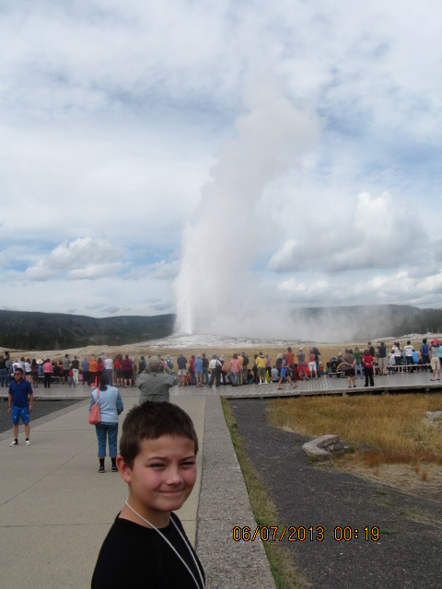
Gotta stop at Old Faithful—a must see (and it was on time—even better).
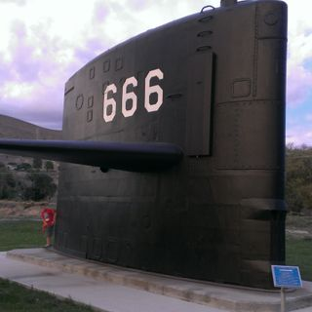
USS Hawkbill (SSN666) conning tower in Arco, Idaho.

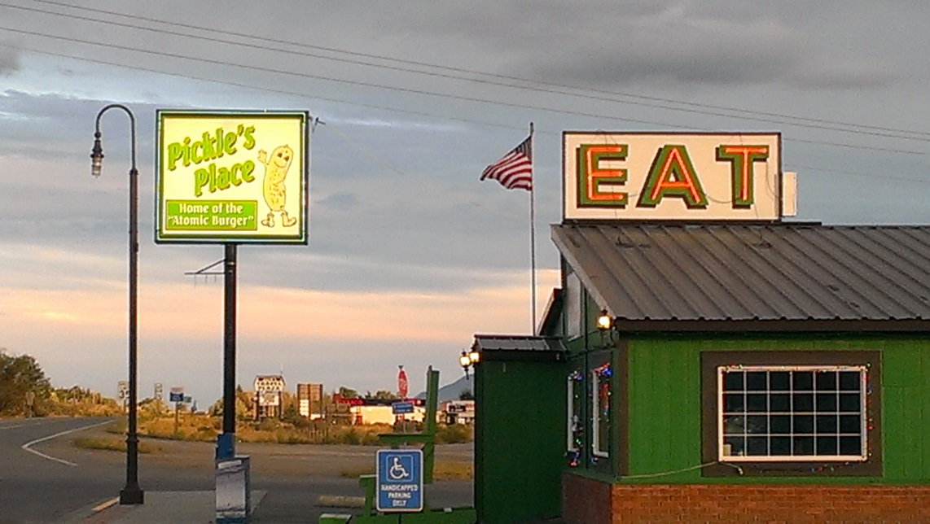
Pickle’s Place, Arco, ID. Good food and friendly service. This is a view from our motel-
DK Motel (clean, quiet and inexpensive).

Day 7. Last post for this trip. We left Arco, ID behind after having breakfast at Pickle's Place (yes, I bought a world famous Pickle's Place Tee Shirt and took pictures). Fall has arrived in southern Idaho—we added another layer (fleece jackets under riding jackets and heavy gloves to stay warm). That additional layer was just about right, as it was in the low 40's early in the morning. The sun coming up helped warm up the ride. Isaac flirted with the waitress and the cook at Pickle's, asked for Idaho potatoes, which netted him a huge pile of hash browns and a big smile from the waitress. I need to keep a tight leash on that boy. Were they actually Idaho potatoes? Unknown. He ate them all PLUS biscuits and gravy. We headed south on US 93 to the Craters of the Moon National Monument. This area is very stark. Volcanic rock covers most of the area --very BLACK---everywhere--like a different planet. Oh yea--Craters of the Moon. There is a connection. Rolled to Twin Falls, ID and then on to Wells, Nevada to pick up I80. We (as in I) decided to press for home instead of spending the night in Winnemucca, NV. I have made better choices -- this was not one of them. It seemed like a good idea at the time though. So we went for it. We rolled across I80 to Winnemucca. It was very windy. Speed limit is 75 mph (the legal one is anyway). Headed south on US 95 to Fallon, NV and then on to Hawthorne, NV. The legal speed limit is 70 mph--on a two lane highway--Dan speed limit--higher. Fallon has a U.S. Navy base where fighter aircraft wings attached to the aircraft carriers practice both bombing and air combat techniques before deployment. Hawthorne has a very large U.S. Army base that is used for disposal of explosives and ordnance (things that go BOOOM). Its gas and a rest break in Hawthorne, then head out on NV 359 to CA 167. We came into California north of Mono Lake up by Yosemite National Park -- where the fires are raging. Smoke is so thick that at 4 PM it appeared to be twilight. Burning eyes and that campfire smell permeated our gear. We headed south on US 395 to Bishop, CA where we anticipate our last rest stop and fuel up. Now this is where another adventure begins. Because 'WE' decided to roll on home I was unaware of the rain storm just south of Lone Pine, CA. The silly thing is I added an app to my phone to get weather forecasts from NOAA—but didn’t use it when we were in Bishop with plenty of 4G signal ( a bad oversight on my part). It is now dark. Riding at night is fine--but add rain showers and it gets dicey. Suffice it to say we survived about 10 miles of rain showers at night -- slow is the magic to survival--and this is one you survive. "Stop--you bozo," you might say. "Nowhere to shelter -- in the great southwest south of Lone Pine, CA, out in the open with lightning accompanying the rain showers,” I respond . Go back or press on? Press on. After that it was a quick dash to Inyokern -- a bit more rain-- and home. One last tip-over puts paid to the trip outside the house. Isaac bailed and so did I at the stop sign across the street from home sweet home. The bike is easy to pick up. No damage or injuries—only my pride—again. Journey’s end comes when we pull into the garage. At the end of the ride—an admission, finally, from Isaac—he also has an aching butt. My problem is it took him 3000 miles to get it. Mine was much shorter. It just isn’t fair! Youth is wasted on the young! I am VERY tired. Arrival 10:15 PM local. A 14 hour day--too long.
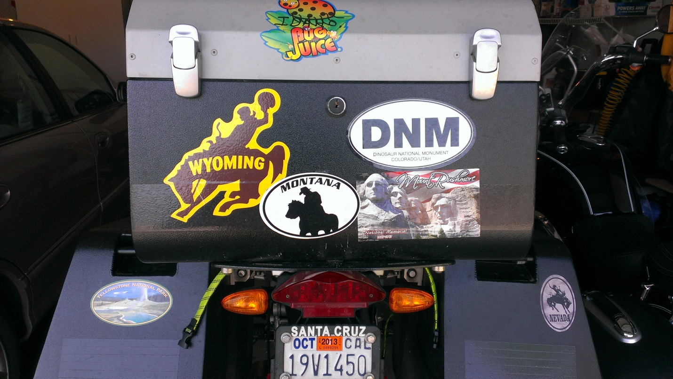
The Idaho sticker ( Bug Juice) was made on the spot by a friendly cashier at a gas stop just before we rolled into Nevada.
End of Day 837 miles from Arco, ID to Ridgecrest, CA--Good Bye Pickle's--Hello Momma.
End of trip 3217 miles in 7 days. BEAUTIFUL COUNTRY! Pictures to follow--I hope.

